Exploration of primary glioblastoma Single-cell RNA-seq co-expression networks

Brian Arand, Raghu Machiraju, Kun Huang

**Abstract.**

1. Introduction

The isolation of individual cells’ transcriptome profiles has been largely a theoretical concept to bioinformaticians. And accordingly, transcriptomic inquiry has been limited to those questions regarding tissues— potentially composed of a heterogeneous hodgepodge of cellular types, subtypes, and states. But with the advent of Single-Cell RNA sequencing (RNASeq) technology, comes the potential for refined resolution in transcriptomic datasets. And expectedly, recent publications suggest a peaking interest in this new landscape of informatics. It has been shown that many bioinformatics techniques that were developed for population-cell tissue samples can be effectively applied to single-cellular datasets. However, co-expression network analysis has largely been an unexplored area of analysis in regards to single-cell RNASeq data. To fill this gap, we leverage this new technology to construct and analyze gene co-expression networks for primary glioblastoma single-cell samples. Glioblastoma is widely known to be a heterogeneous cancer, making it a prime candidate for single-cellular inquiries. For instance, it is hypothesized that the averaging of single-cells’ profiles within a tissue sample may mask or otherwise confound downstream gene correlations based analysis.  Correlation between two genes may exist across tissue samples purely due to changing proportion of cellular subtypes within those samples. However, a single-cellular perspective, of the same tumors may theoretically filter out those artificial tissue-level correlations. And so correlation based analysis, like co-expression network analysis, require study. In our work, we begin this journey by looking at network mining, module detection, and gene enrichment analysis at both the single-cell and population of cell (tissue sample) levels. The final goal of this work is to shed light on the convoluted intricacies of inter-cellular genomic landscape of glioblastoma tissue from a single-cellular perspective.

1. Methods
   1. Single-Cell RNASeq Samples

We analyzed GSE57872: the data presented by Patel et al. in Single-cell RNA-seq highlights intratumoral heterogeneity in primary glioblastoma . This data is comprised of normalized gene expression values for 5,948 genes for 430 single-cell samples selected by flow cytometry cell sorting and micromanipulation from 5 different primary glioblastomas labeled: MGH26, MGH28, MGH29, MGH30, and MGH31. The cells were then sequenced using SMARTseq protocol . Alignment to hg19 was performed with Bowtie (version 1.1.1) and the authors calculated TPM (transcripts per million) values using RSEM (version 1.2.3) .The final reported values were log-transformed and mean-shifted per gene. More formally, let *xsi*be the TPM enrichment value for the *i*th geneof sample *s*. And let *Nt* be the sample size of tumor *t*, then the analogous, final reported value, *ysi*, would be:

### Network Construction

In our analysis, single-cell samples were grouped by tumor of origin, t. For each group, a gene-by-gene Spearman’s rank correlation matrix was calculated:

Where is the Spearman’s correlation between the *i*th and *j*th gene of tumor t. Co-expression matrices were then created by filtering at the same Spearman’s rank threshold, *c*, to produce binary matrices, Bt, per tumor.

This is analogous to cutting a co-expression network at a given edge threshold. After analyzing the distribution of resulting networks’ densities (Figure 1.a) we settled on a threshold of 0.3 with an associated frequency network density of (0.04). We point out that this threshold is low, but we argue that it is a necessary trade-off given the distribution of correlations (Figure 1.b). It is expected to see such non-concordant data, because current single-cell RNASeq technology is known to produce noisy data (need a reference for this).

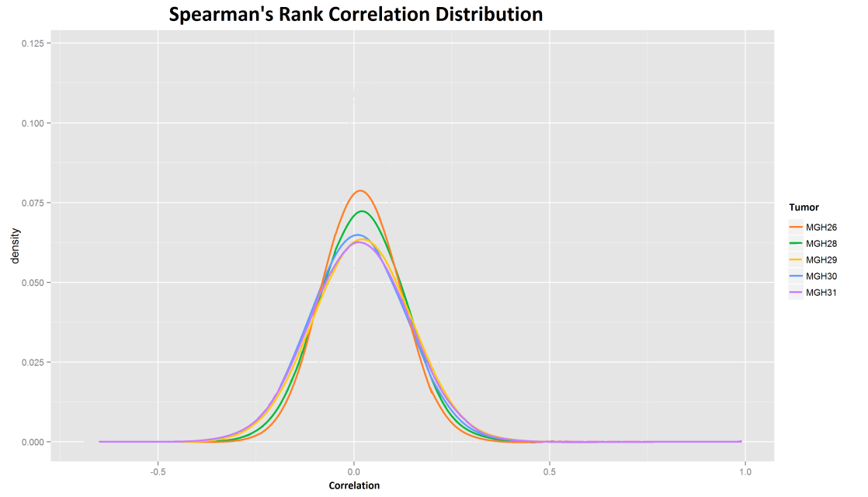**Fig. .** **Single Cell Correlation** We examine the distribution of edge weights in each tumor noting that there are not many highly correlation genes. This is theorized to be due to the noisiness of single-cell data. Accordingly we set a low correlation threshold of *c* = 0.3 when constructing the binary matrix in equation (4).

The binary matrices were then aggregated into a single frequency matrix, *F*. This aggregation is performed in an attempt to attenuate patient-specific signals and focus, rather, on glioblastoma-specific patterns of gene co-expression.

### Module Detection

This frequency matrix was then fed into the CODENSE software to be converted into a summary network, S, and then mined for high-density modules .

CODENSE then reported the modules that meet some minimum density threshold, *d*. At the suggestion of the CODENSE authors and after analyzing the effect perturbing *d* has on the number and size of the resulting modules, we chose a minimum density threshold of 0.6. We wanted to maximize our parameter d to ensure dense modules to ensure their biological significant. Note that in figure 2, heightened values of d can produce can drastically affect the output number and size of modules. Our selection of d = 0.6 marks the upper limit of where this non-robust behavior starts in our selected parameter space sampling resolution. At the selected parameterization CODENSE reported 21 dense, first-order modules. These relatively high thresholds will guarantee that our resulting modules will be dense and highly representative of tumors as a whole rather than dominated by signal from just a single tumor of origin (see Figure 2). We find that these are necessary steps in order to extract meaningful co-expression from data that is relatively noisy and will so few tumors of origin to work with.

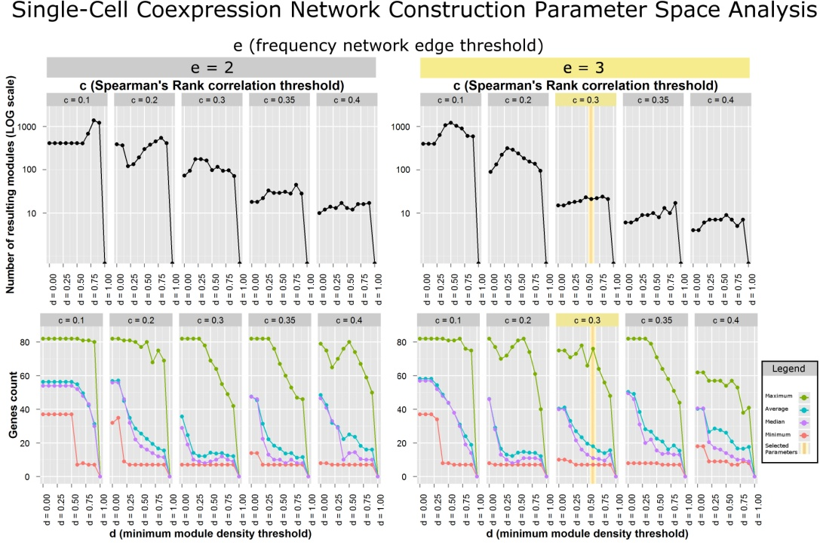

**Fig. .** **Parameter Space Exploration** We performed an exhaustive exploration of the parameter space involved in the cutting of our Spearman’s Rank matrix with parameter *c*, the building of our frequency matrix with parameter *e,* and the filtering of our detected modules with parameter *d*. The top charts characterize the number of resulting modules, while the bottom two charts characterize the minimum, maximum, median, and average number of genes in those resulting modules at various selections of *c*, *e*, and *d*. Selected parameters are shown in yellow. They were selected for the desirable number of resulting modules and module sizes as well as the robustness of these values in the immediate parameter space.

* 1. Population Tissue Samples

Our population-tissue control comes from GEO accession GSE48865. 272 glioma tissue samples make up this dataset, of which, 59 were identified as primary, stage-4 glioblastoma tissue samples. We filtered out any reads from the 59 samples with more the 10% of its nucleotides designated as unknown bases, and any read with more than 50% of its bases having Sanger phred+33 quality scores less than 5. After filtering, we retained 1,388,064,773 reads in total.

Each filtered sample was then aligned to hg19 transcriptome (GRCh37) using bowtie (version 1.1.1 with default parameters provided by RSEM) and TPM values per gene were estimated using RSEM (version 1.2.3). 73% of the reads were aligned successfully either uniquely or multi-mapped.

TPM values were adjusted again as in equation (2). Genes were then filtered to retain only those that were highly expressed across the 59 samples—the *i*th gene was filtered out if *yi* <= 4.5. We retained 6,932 genes after filtering.

### Network Construction

Spearman’s Rank correlation was calculated for all genes pair-wise. No further network aggregation step was required for this data set.

### Module Detection

Quasi-Clique Merger (eQCM) was employed to mine the modules in the population sample network with parameters: …

* 1. Enrichment

Module sets derived from both the single-cell network and population tissue sample network were then ontology enriched. Modules were enriched for all terms in Gene Ontology Consortium’s biological process (BP), cellular component (CC), and molecular function (MF) human ontologies using the David Bioinformatics Resources (version 6.7) Functional Annotation Tool .

1. Results
   1. Single-Cell Module Enrichment

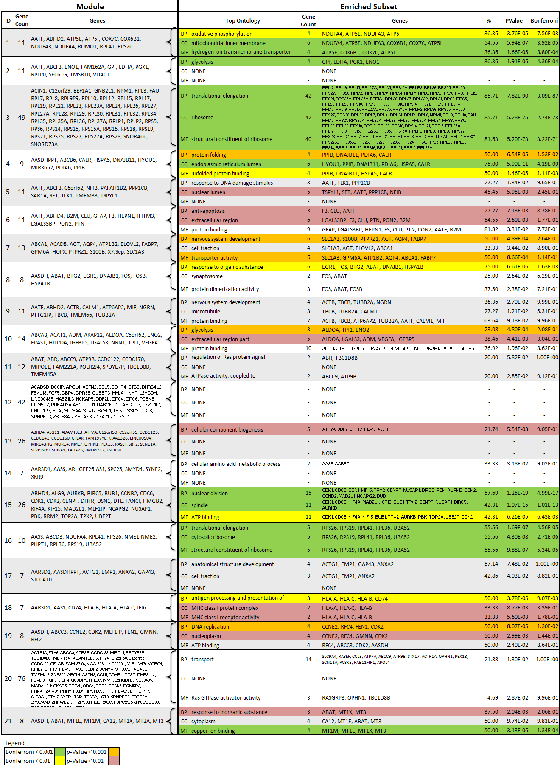

* 1. Population-Sample Module Enrichment

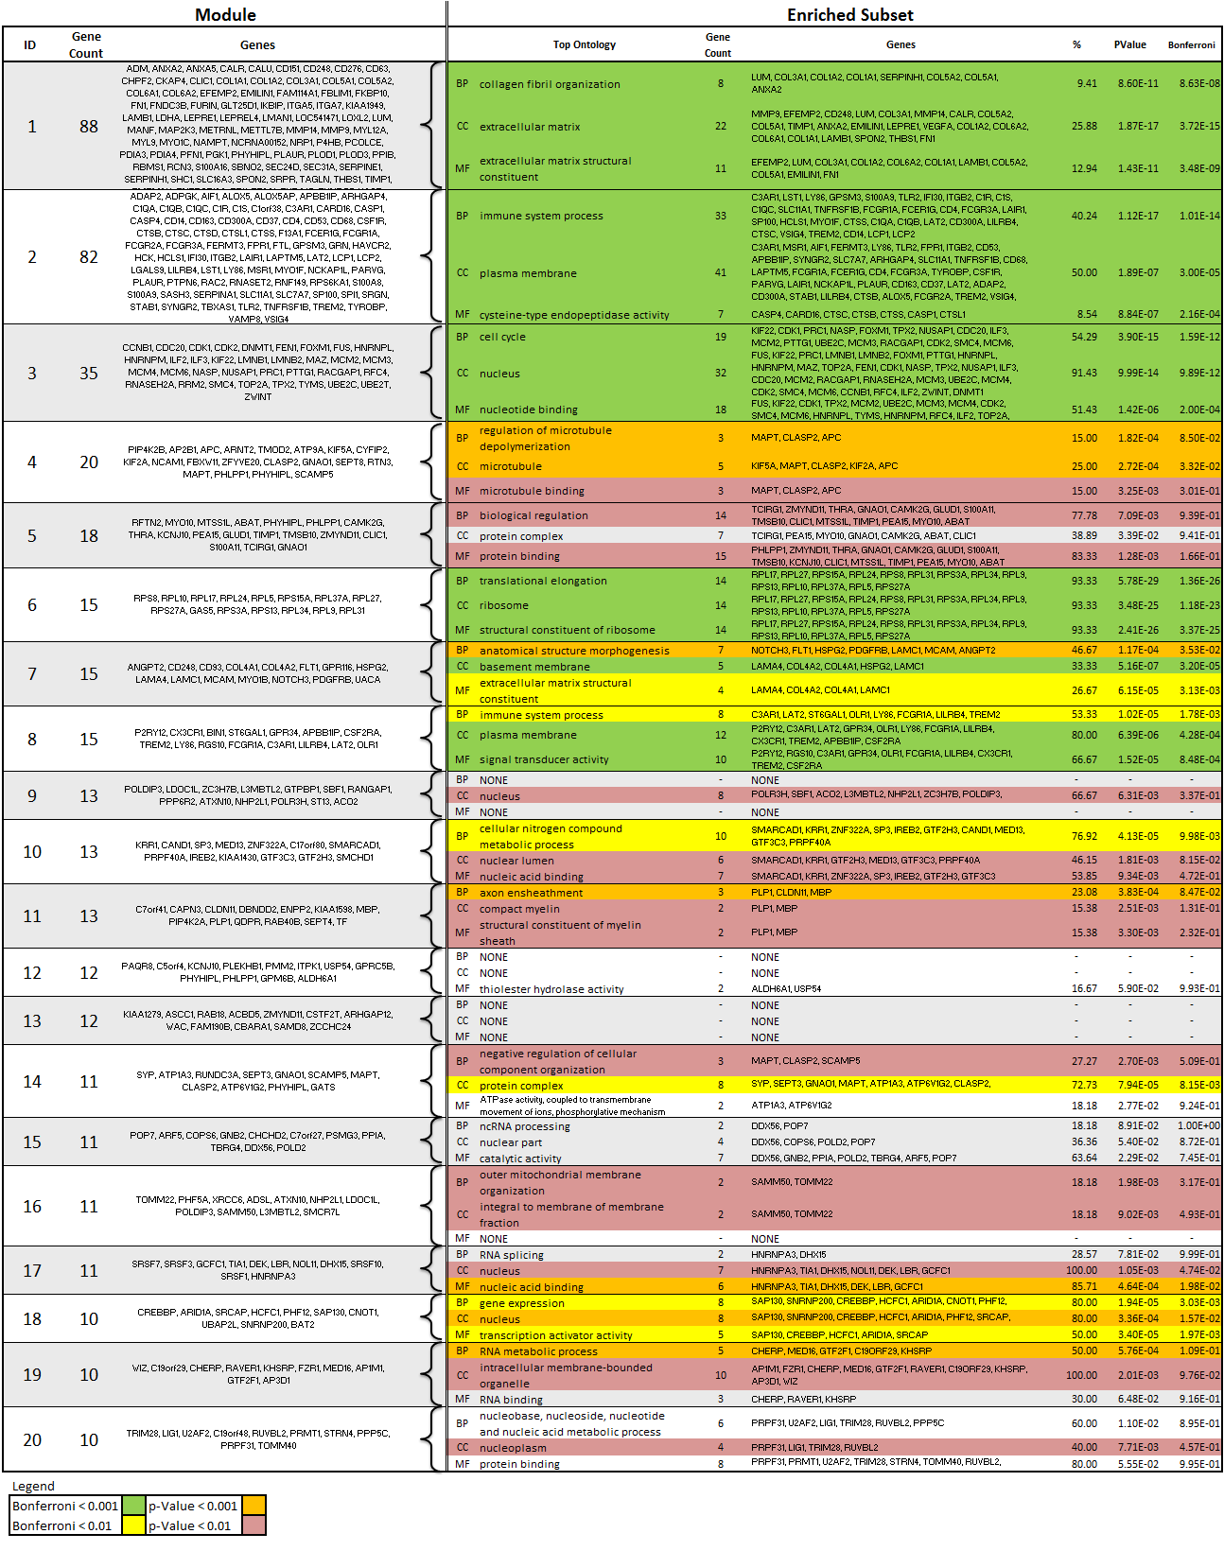

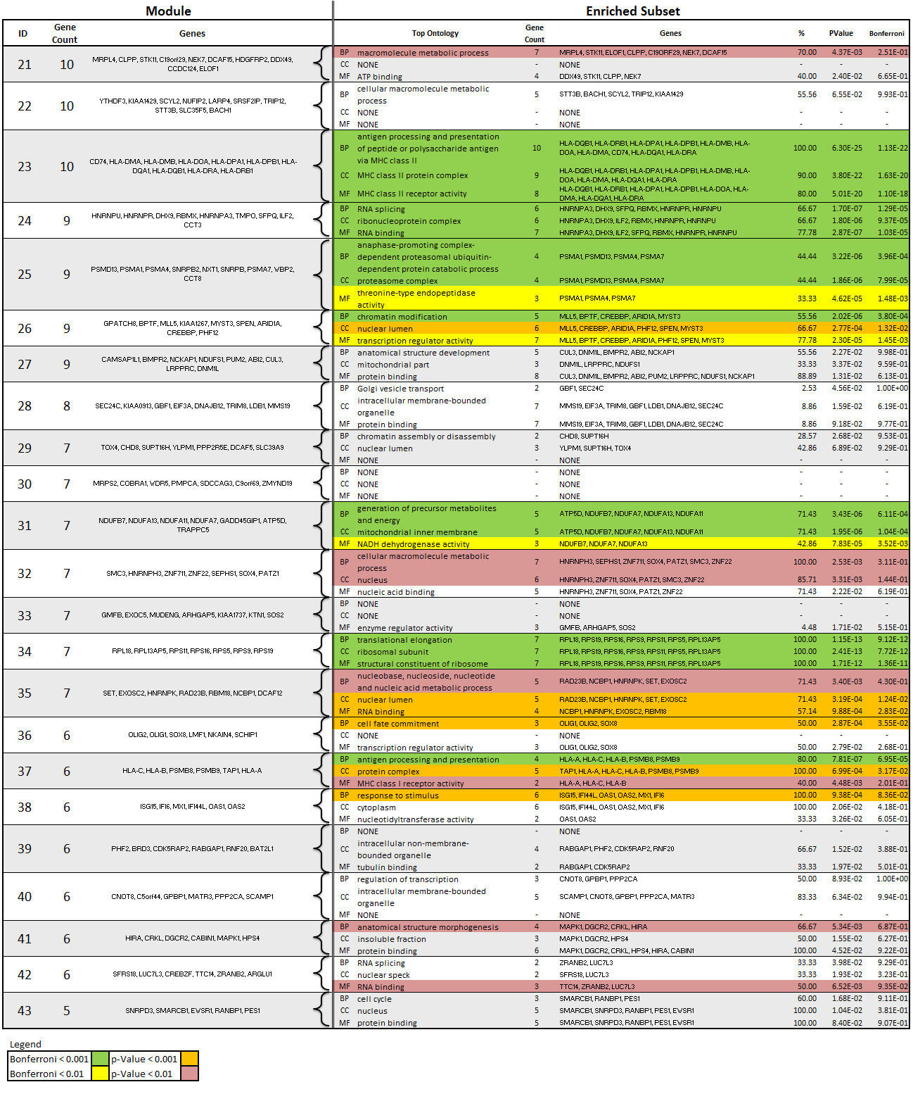

1. Discussion

Compare with Yang paper

Cell cycle and extra cellular matrix ontologies are less

Caveats:

Not many tumors in study and thereby not many original networks before aggregation into frequency network.

1. Conclusion
2. References

Bao, Z.-S., Chen, H.-M., Yang, M.-Y., Zhang, C.-B., Yu, K., Ye, W.-L., et al. (2014). RNA-seq of 272 gliomas revealed a novel, recurrent PTPRZ1-MET fusion transcript in secondary glioblastomas. *Genome Research* *, 24* (11), 1765-1773.

Hu, H., Yan, X., Huang, Y., Han, J., & Zhou, X. J. (2005). Mining coherent dense subgraphs across massive biological networks for functional discovery. *Bioinformatics* *, 21* (suppl 1), i213-i221.

Huang DW FAU Huang, D. W., Sherman BT FAU Sherman, B. T., & Lempicki RA FAU Lempicki, R. A. (n.d.). Bioinformatics enrichment tools: paths toward the comprehensive functional analysis of large gene lists. *Bioinformatics enrichment tools: paths toward the comprehensive functional analysis of large gene lists* *(1362-4962 (Electronic))* , --.

Huang, D. W., Sherman, B. T., & Lempicki, R. A. (2008). Systematic and integrative analysis of large gene lists using DAVID bioinformatics resources. *Nat. Protocols* *, 4* (1), 44-57.

Langmead, B., Trapnell, C., Pop, M., & Salzberg, S. (2009). Ultrafast and memory-efficient alignment of short DNA sequences to the human genome. *Genome Biology* *, 10* (3), R25.

Li, B., & Dewey, C. (2011). RSEM: accurate transcript quantification from RNA-Seq data with or without a reference genome. *BMC Bioinformatics* *, 12* (1), 323.

Patel, A. P., Tirosh, I., Trombetta, J. J., Shalek, A. K., Gillespie, S. M., Wakimoto, H., et al. (2014). Single-cell RNA-seq highlights intratumoral heterogeneity in primary glioblastoma. *Science* *, 344* (6190), 1396-1401.

Xiang Y FAU Xiang, Y., Zhang CQ FAU Zhang, C.-Q., & Huang K FAU Huang, K. (n.d.). Predicting glioblastoma prognosis networks using weighted gene co-expression network analysis on TCGA data. *Predicting glioblastoma prognosis networks using weighted gene co-expression network analysis on TCGA data* *(1471-2105 (Electronic))* , --. The Comprehensive Cancer Center Biomedical Informatics Shared Resource, The Ohio State University, Columbus, USA.

Zhang, J. a.-w. (2012). Weighted Frequent Gene Co-expression Network Mining to Identify Genes Involved in Genome Stability. *PLoS Comput Biol* *, 8* (8), e1002656.